*WELCOME*

****

**A MINI PROJECT REPORT**

**ON**

***“Patanjali Online Shop”***

SUBMITTED

BY

**Bhavar Sudarshan Gokul (07)**

**Bramhane Vipul Vilas (09)**

**Vikhe Shubham Dilip (78)**

GUIDED

BY

**Prof. Kharde Sir**

**DEPARTMENT OF COMPUTER ENGINEERING**

PRAVARA RURAL ENGINEERING COLLEGE, LONI

(SAVITRIBAI PHULE PUNE UNIVERSITY)

ACADEMIC YEAR 2021-22

DEPARTMENT OF COMPUTER ENGINEERING

PRAVARA RURAL ENGINEERING COLLEGE, LONI

(SAVITRIBAI PHULE PUNE UNIVERSITY)

**CERTIFICATE**

This is to certify that

**Bhavar Sudarshan Gokul (07)**

**Bramhane Vipul Vilas (09)**

**Vikhe Shubham Dilip (78)**

of class T.E.Comp have successfully completed their mini project work on “Patanjali online Shop” at PRAVARA RURAL ENGINEERING COLLEGE, LONI Name in the partial fulfilment of the Graduate Degree course in T.E at the Department of Computer, in the Academic Year 2021-22 Semester-v as prescribed by the Savitribai Phule Pune University.

Date : / /2021

**Contents:**

***Index***

|  |  |
| --- | --- |
| ***Sr.no*** | ***Title*** |
| ***1*** | ***Introduction*** |
|  | *1.1 Proposed System* |
|  | *1.2 Need for System* |
|  | *1.3 Scope of System* |
| ***2*** | ***Feasibility Study*** |
| ***3*** | ***Fact Finding Technique*** |
| ***4*** | ***Requirement Analysis*** |
| ***5*** | ***Analysis And Design*** |
|  | *5.1 E-R Diagram* |
|  | *5.2 Class Diagram* |
|  | *5.3 Object Diagram* |
|  | *5.4 Use Case Diagram* |
|  | *5.5 Sequence Diagram* |
|  | *5.6 Activity Diagram* |
|  | *5.7 Component Diagram* |
|  | *5.8 Deployment Diagram* |
| ***6*** | ***Data Dictionary*** |
| ***7*** | ***Input Output Screen*** |
| ***8*** | ***Advantages of System*** |

## Introduction:

##### Background

The purpose of this document is to define the features of the E-Commerce Website. Here Visitors can see the publicly available features such as browse products, view details of products (Size, Colour and Cost), and view other static contents of site. Registered User can view all publicly available features and in addition to this they can purchase the products by adding them into shopping cart. Admin can manage all the contents and Orders from the Backend (admin side)

Types of Users of the website are: Visitors

Customers (Registered Member) Admin.

***Need for the System***

***Consider a scenario...***

***There are 3-4 departments and we are suppose to maintain the records of each transaction about the stock how much are sold, how much left, how much is profit and how much is loss etc.***

***In manual system to maintain the records of each transaction is very difficult, complex and time consuming. This degrades the performance of the system.***

***To solve the manual problem the computerization is needed. Which Increase overall performance, accuracy of the system. We can keep daily transaction reports having centralized control over the system. By saving Time, careless Errors during data entry, this system also reduces manpower.***

## *Proposed System*

***The computerized system was needed because there were following drawbacks in the past manual system.***

* ***Keeping a record of all entered was a very tedious job.***
* ***Searching a particular entry was tedious because it involved searching all entries which required more time.***
* ***The cost for maintenance is eliminated.***
* ***Manual system is difficult and time consuming.***
* ***Due to computerization data storage and retrieval is done efficiently .***
* ***Human errors are reduced.***
* ***Makes system user friendly.***
* ***Current records can be matched with the past records which improves planning & implementation.***

## *Scope of System*

***We have developed a project named, “INVENTORY MANAGEMENT SYSTEM”. This system helps to maintain all transactions related to the Inventory. The details such as product id, product name, price, date of manufactured, expiry date are stored so that the user can see the details of the product on the computer itself.***

***The administration has the right to add, delete or modify the product entry. The system also maintains records of supplier to whom the products are issued.***

***The system helps to maintain the information about name, address, and contact number of customers. The system also helps to maintain the information like price, quantity, total price, and date purchased, manufacturing date, expiry date of the product.***

##### PRICE

A Fixed Price engagement model for the development E-Commerce Website Based on the document provided, we propose following detailed in the section Fixed Price of development of E-Commerce Website stated in scope section is [private] The pricing details associated with this engagement are detailed:



##### COST ESTIMATION

Cost Estimation: **Items Cost (GBP)**

Delivery (Development + QA) **x**

User Acceptance Test Support – -

Beta Release

(Post Delivery – 4 weeks)

**Total Cost of Project x**

|  |  |  |
| --- | --- | --- |
| **Milestone of payment schedule** | **Item** | **% of price** |
| Milestone 1 | Award of Project | 50% |
| Milestone 2 | After First Demo on Development Server | 30% |
| Milestone 3 | After Final Demo on  Development Server | 20% |

## The Scenario

A small grocery store, for online business to supply a community with organic products, Due to long-standing customer base and increasing affluence to the area, the store has decided to investigate the possibility of providing an online delivery service to the customer.

The grocery store staff has asked you, the Java web developer, to create a website that will enable their customers to shop online. They have also asked that you create an administration console alongside the website, which will allow staff members to keep track of orders. The security and safety of system and customers’ information should be highly prioritized. Every customer must be register on our online grocery store before they purchase any product and display some terms and conditions about our grocery store, customer with explicit consent of terns service solely can purchase and costumer needs to pay online.

##### User Interface:

* 1. **Pages**
     1. Home Page
        1. Header will contain logo, menu, about, contact, profile (if logged in), and login/logout options.
        2. User will see THANK YOU message after successful login
     2. About Us
        1. This page contains information about the website.
        2. Couple of sentences about your website
     3. Contact Us
        1. User can contact through Email
        2. Through Cell
        3. Through Social Media

##### Item Selection:

* + 1. Item Brand
    2. Item Size
    3. Item Price
    4. Item verities

##### Delivery

* + 1. Customers Name
    2. Customers Complete Address
    3. Customer Cell
  1. An online representation of the products that are sold in the physical store. There are many categories (e.g. dairy, meats, bakery, fruit etc.), and every product for each category, which online shoppers can browse. Details are provided for each product (i.e., name, image, description, and price)
  2. Shopping cart functionality, which includes the ability to:
     1. Add items to a virtual shopping cart.
     2. Remove items from the shopping cart.
     3. Update item quantities in the shopping cart.
     4. View a summary of all items and quantities in the shopping cart.
     5. Place an order and make payment through a secure checkout process.
  3. An administration console, enabling staff to view customer orders.

##### SCOPE OF THE PROJECT

The objective of this project proposal is to define the project scope of E-Commerce Website and to provide the Estimation. The advantage would be simple user interface that is easy to understand by all type of users.

##### SCOPE

The scope document is defined after discussing with **the Client**

##### Design Goals

The application consists of following main things:

##### Visitor Features

View Home Banners or Slide Show Gallery Browse Products

View Product Details View FAQs

Become a Member through Registration process View Static Pages

##### Registered Member Panel

Login to site Manage Account My Profile

My Orders

Buy Product (Checkout) Logout

***ENTITY RELATIONSHIP***

***An entity is an object that exists & has distinguishing feather for identification . An entity is anything that plays a specific role in the system being developed . It can be taken from the categories by person , places , things , documents , etc.***

***An entity is described by its various attribute. Two entity are related with one another , if there is some association present between them . This relation is shown with the help of entity relationship diagrams .***

***Relationship between entity can be qualified by their mapping attribute , which express the number of entity to which the another entity can be associated , this may be one-to-one , many-to-many , many-to-one & one-to-many .Here,***

***1. Rectangle represents entity sets***

***2. Ellipse represents attributes***

***3. Diamond represents a relationship set***

***4. Lines represent link between two entity set***

***E-R Diagram***

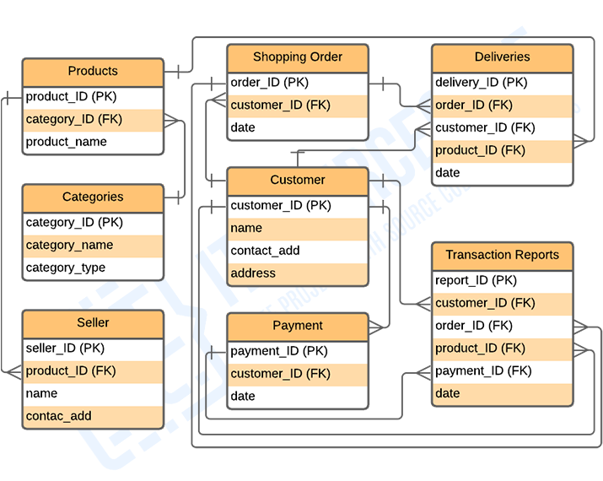

***Class Diagram***

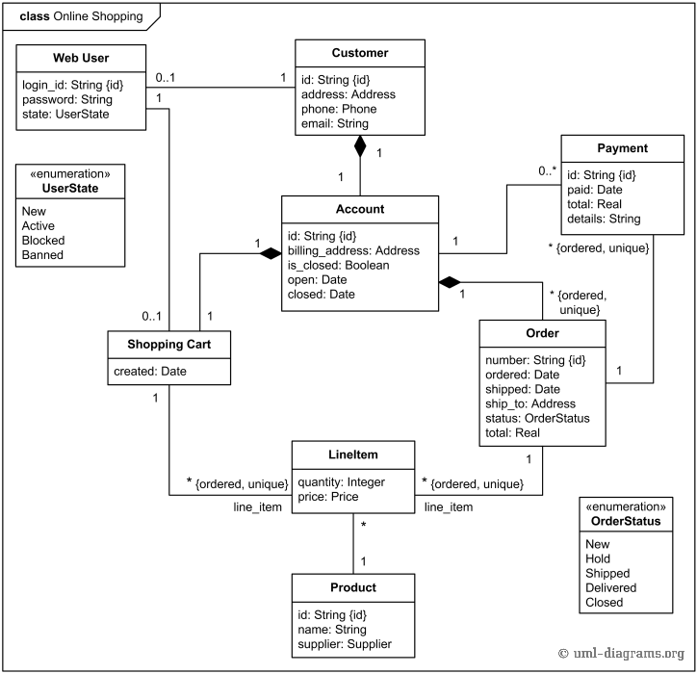

***Use Case Diagram***

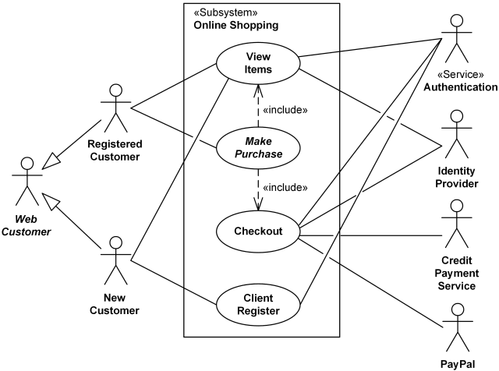

**Admin Panel** Login Dashboard

Administrator User Management

Site Member(Customer) Management Blind Type Management

Product Attribute Management Product Management

Price Chart Management Banner Manager

Order Manager Shipping Management

##### High level Requirements

***System Block Diagram***

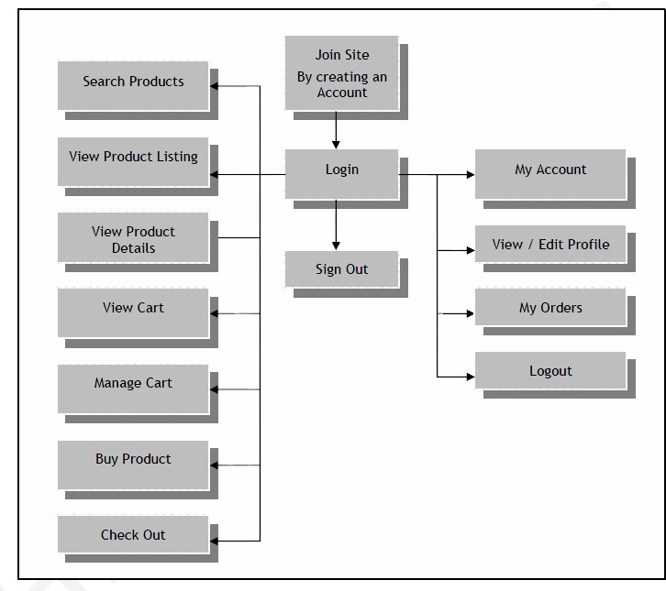

1. **User Registration**
   1. User will register before purchasing any product.
   2. Registration form will contain e-mail, user name, password and home address.
   3. Security, in the form of protecting sensitive customer data while it is transferred over the Internet, and preventing unauthorized access to the administration console.
   4. After enter user details then display terms and conditions for user in which user need to confirm and read our conditions.
   5. Display a welcome message to user after successful registrations.

#### Terms & Conditions

* 1. **Privacy Policy.** Our privacy policy, which sets out how we will use your information, can be found at [Privacy Policy Link]. By using this Website, you consent to the processing described therein and warrant that all data provided by you is accurate.
  2. **Prohibitions.** You must not misuse this Website. You will not: commit or encourage a criminal offense; transmit or distribute a virus, Trojan, worm, logic bomb or any other material which is malicious, technologically harmful, Breaching this provision would constitute a criminal offense.
  3. **Intellectual Property, Software and Content.** The intellectual property rights in all software and content (including photographic images) made available to you on or through this Website remains the property of [www.example.com.](http://www.example.com/)
  4. **Terms of Sale.** By placing an order you are offering to purchase a product on and subject to the following terms and conditions. All orders are subject to availability and confirmation of the order price.
     1. **Our Contract.** When you place an order, you will receive an acknowledgement e-mail confirming Receipt of your order.
     2. **Pricing and Availability.** Whilst we try and ensure that all details, descriptions and prices which appear on this Website, are accurate, errors may occur.
     3. **Payment** Upon receiving your order we carry out a standard authorization check on your payment Card to ensure there are sufficient funds to fulfill the transaction.
  5. **Complaints.** We operate a complaints handling procedure which we will use to try to resolve disputes when they first arise, please let us know if you have any complaints or comments.
  6. **Entire Agreement.** The above Terms of Service constitute the entire agreement of the parties and supersede any and all preceding and contemporaneous agreements between you and [www.example.com.](http://www.example.com/) Any waiver of any provision of the Terms of Service will be effective only if in writing and signed by a Director of [www.example.com](http://www.example.com/).

#### Shipping policy and Delivery Time-frame

* 1. **Shipping policy should easily accessible.** Don’t require visitors to log in or create accounts, before they can view our shipping policy. Visitors to our website will need to know the shipping terms before they place an order. An unpleasant surprise at the checkout will almost certainly lead to a lost sale.
  2. **Shipping policy must be accessible from all pages.** Placing a link within

website’s header or sidebar will usually do the trick.

* 1. **Provide all shipping details at the checkout.** Tell customers how much Each shipping option will cost and how long it will take. Provide full details on international shipping, if applicable.
  2. **No overcharge for shipping.** It should be clear that shipping is absolutely free.
  3. **Provide detailed delivery time-frames.** List delivery time-frames for each shipping option by delivery region.
  4. **Provide tracking information.** Email the shipment’s tracking number to

customer as soon as it is available. Being able to track his order, customer will know at any given time exactly what the status of the shipment is.

* 1. **Responsibility for lost shipments.** Whenever a shipment is lost, take

responsibility and re-ship it. It may not be our fault, and it probably won’t be, but customer has placed an order with our business and will rightly hold us responsible for it.

## System Specification

We will use Agile method through whole project.

And we will use PHP5, HTML, CSS, AJAX Javascript in this project. System will be designed on The Basis of above user requirements.

##### User Interface:

* 1. **Pages**
     1. Home Page
     2. Header (logo, menu -> about, contact, [profile <- if logged in], login/logout)
     3. Display THANK YOU message after login successfully
     4. Simple hero shot and marketing message
     5. About Us
        1. Couple of sentences about your website
     6. Contact Us
        1. Through Email
        2. Through Cell
        3. Through Social Media

##### Item Selection:

* + 1. Item Brand
    2. Item Size
    3. Item Price
    4. Item verities

##### Delivery

* + 1. Customers Name
    2. Customers Complete Address
    3. Customer Cell
  1. An online representation of the products that are sold in the physical store. There are many categories (e.g. dairy, meats, bakery, fruit etc.), and every product for each category, which online shoppers can browse. Details are provided for each product (i.e., name, image, description, and price)
  2. Shopping cart functionality, which includes the ability to:
     1. Add items to a virtual shopping cart.
     2. Remove items from the shopping cart.
     3. Update item quantities in the shopping cart.
     4. View a summary of all items and quantities in the shopping cart.
     5. Place an order and make payment through a secure checkout process.
  3. An administration console, enabling staff to view customer orders.

1. **User Registration Requirements:**

##### Build value around registration.

Before users create an account you need to explain the reason for creating an account.

##### Eliminate as many fields as possible.

Only get data from user which are most important and remove or make all other fields as "Optional" which are not necessary about user.

##### Group fields logically

Some sites gather a lot of information in registration form like shipping address, billing address etc,

So many users want to deliver their personal information in certain order. And we need an order for user registration.

##### Break up long registration processes into steps.

And finally bread down all the processes into a well steps.

##### Make your security and privacy policies clear as day.

Make sure that the user who is creating an account on our website is secure. And include a clear link of our privacy policy.

##### Make password recovery easy.

If a user forgets his password or loses their password in some cases, so we want a password recovery link in our both registration and login form.

##### Give the option to refresh captcha.

in order to secure website from robots usage. So we want a captcha code for users to enter it while creating an account**.**

##### Give a PayPal method.

Before users enter into their accounts while in registration they need to confirm their account on PayPal or any other bank account.

##### User Login System:

It is necessary for every user to login into their accounts before they move to purchase any product from our website.

We want a user email and password in login form for the users.

##### Admin Panel:

We want an admin panel in which we can control all the information/data about our website like we can insert a new data from admin panel and delete that data about product which are not available in our shop/market. And our admin panel must be secure in which only two admin can access to our admin area and edit / delete the data.

And we have user’s information in our admin area So that we can easily check the user’s detail.

given time exactly what the status of the shipment is.

* 1. **Responsibility for lost shipments.** Whenever if a shipment is lost, take

responsibility and re-ship it. It may not be our fault, and it probably won’t be, but customer has placed an order with our business and will rightly hold us responsible for it.

**SOFTWARE TESTING**

**Is the menu bar displayed in the appropriate contested some system related features included either in menus or tools? Do pull**

**–**

**Down menu operation and Tool-bars work properly? Are all menu function and pull-down sub function properly listed; Is it possible to invoke each menu function using a logical assumption that if all parts of the system are correct, the goal will be successfully achieved. Inadequate testing or non-testing will leads to errors that may appear few months later.**

**This create two problems.**

**1. Time delay between the cause and appearance of the problem.**

**2. The effect of the system errors on files and records within the system.**

**The purpose of the system testing is to consider all the likely variations to which it will be suggested and push the systems to limits.**

**The testing process focuses on the logical intervals of the software ensuring that all statements have been tested and on functional interval is conducting tests to uncover errors.**

## *Advantages of System*

* ***Human errors are reduced.***
* ***Data storage is done efficiently.***
* ***Data retrieval is faster.***
* ***Keeping a record of all entered was a very tedious job.***
* ***Searching a particular entry was tedious because it involved searching all entries which required more time.***
* ***The cost for maintenance is eliminated.***
* ***Makes system user friendly.***
* ***Our system provides two types of user administrator and local user which have a limited functionality. It improves the security.***
* ***Only the Users who have administrative rights are allowed to create or modify users and unlock/lock users***
* ***The reports can be generated for***
* ***Monthly Customer bill***
* ***Monthly Product Sale***
* ***Monthly Product Purchase Monthly Turnover***

## *Future Enhancements*

* ***The system is very useful in any kind of Inventory Systems by making minor modifications. This makes it reusable.***

***Online System***

***DRAWBACKS AND LIMITATIONS:***

***The proposed system has some drawbacks and limitations that are as follows,***

***1. This system is not operating as On-line system.***

***2. It cannot produce structured report of daily transaction.***

***3. System cannot worth in Heterogeneous environment.***

***4.It is not Static system for only some departments.***

**Conclusion**

**Our project is only a humble venture to satisfy the needs in an Institution. Several user friendly coding has also adopted. This package shall prove to be a powerful package in satisfying all there requirements of the organization.**

**The objective of software planning is to provide a frame work that enables the manger to make reasonable estimates made within a limited time frame at the beginning of the software project and should be updated regularly as the project progresses. Last but not least it is no the work that played the ways to success.**

***BIBLIOGRAPHY***

bs00554_

* The Complete Reference

–Herbert Scheldt

* The Complete Reference

–James Keogh

**Online References:**

* <http://www.roseindia.in>
* <http://www.stackoverflow.com>

THANK YOU